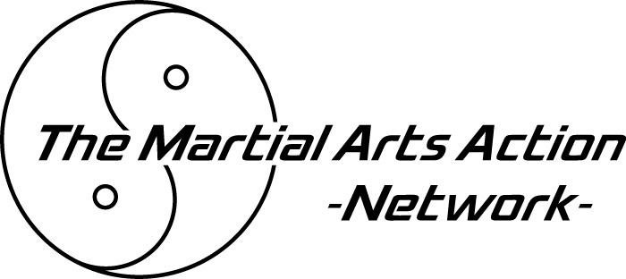

WAIVER FOR SUBMISSION OF
PROGRAM IDEAS AND MATERIALS

Title of Material Submitted: __________________________________________

Date Submitted: ______________Accepted By: __________________________

THE MARTIAL ARTS NETWORK (TMAN) appreciates the submission of program material from outside sources. Frequently, however, these contributions are similar or identical to those developed by our own staff or others. In order to avoid the risk of claims based upon the use of previously or concurrently developed material that may be similar to submissions, TMAN has found it necessary to require a Release Form to accompany all program submissions. Unsolicited material will also not be considered unless this Waiver accompanies program submission. Thank you for your cooperation.

WAIVER

In accordance with your policy concerning submission of ideas and other materials, I am today submitting to you my material(s), which are summarized in attached Proposal pursuant to the following Agreement.
 You agree to cause your appropriate employee having the duty of evaluating material of the type now being submitted by me to review my material(s). I agree that you may use my material(s) or one or more of its features or components. If you commence such use, and provided it is original, novel and valuable, you agree to pay me as total compensation therefore such sum of money as we may subsequently agree upon in writing. I agree that I can suffer no damages in excess of the foregoing from your use of my material(s) or for any other claim with respect thereto.
 I declare that all of the important features of my material(s) are summarized in attached Proposal and I have disclosed no other features to you. I warrant that the material is original with me and that no one else to my knowledge has any right to it. I believe my material(s) and its features to be unique and novel. However, I recognize that other persons, including your own employees, may have submitted to you or to others, or made public, or may hereafter originate and submit, or make public, similar or identical material(s) which you may have the right to use, and I understand that I will not be entitled to any compensation because of your use of such other similar or identical material(s).
● Any controversy arising as to whether you used my material, or relating to this Agreement, will be conclusively determined by Arbitration as provided by Florida law and the regulations of the American Arbitration Association and our Arbitrator will be a person experienced in the broadcasting and cable television industry who will be mutually selected by us. If we cannot agree, we will accept as Arbitrator, any person designated by the President of the County Bar Association who will agree to Arbitration the controversy, in accordance with the rules of the American Arbitration Association. The Arbitrator’s decision shall be controlled by the terms of this Agreement and no award may exceed the appropriate amount specified in Paragraph  of this Waiver. Judgement upon the award may be entered in any court having jurisdiction. I agree that any action against you must be brought within six (6) months after the date of your first use of my material(s).
❍ I have retained a copy of my material(s) submitted to you and release you from liability for, loss of or damage to such material(s).
■ This Agreement constitutes our entire understanding. Any modifications or Waiver hereunder must be in writing, signed by both of us. The invalidity of any provisions hereof is not to affect the remaining provisions. This Agreement applies equally to any other material(s), which I may submit to you, unless agreed in writing to the contrary.
□ No termination of this Agreement and no acts with respect to the material(s) (such as returning it to me) will be deemed to affect our respective rights under Paragraphs  and  (including those as to amount of compensation, agreement to Arbitrate and time for bringing any actions) and such rights will survive any such termination or acts.

NAME: _______________________________________________________________________

ADDRESS: ___________________________________________________________________

CITY/STATE/ZIP_______________________________________________________________

PHONE:______________________________FAX:____________________________________

SIGNATURE:__________________________________________________________________

Proposal Attached:  yes  no

Videotape Submitted:  yes  no

Notes:________________________________________________________________________

Please send this form, along with full submission, to:
Vice President of Programming
THE MARTIAL ARTS NETWORK
1000 Universal Studios Plaza, Bldg. 22A
Orlando, FL 32819
(407) 370-4460  FAX: (407) 370-0857

